PART 1. STARTING THE PROGRAM

1. Copy all the queries from your file.

2. Click on the Files on the left side
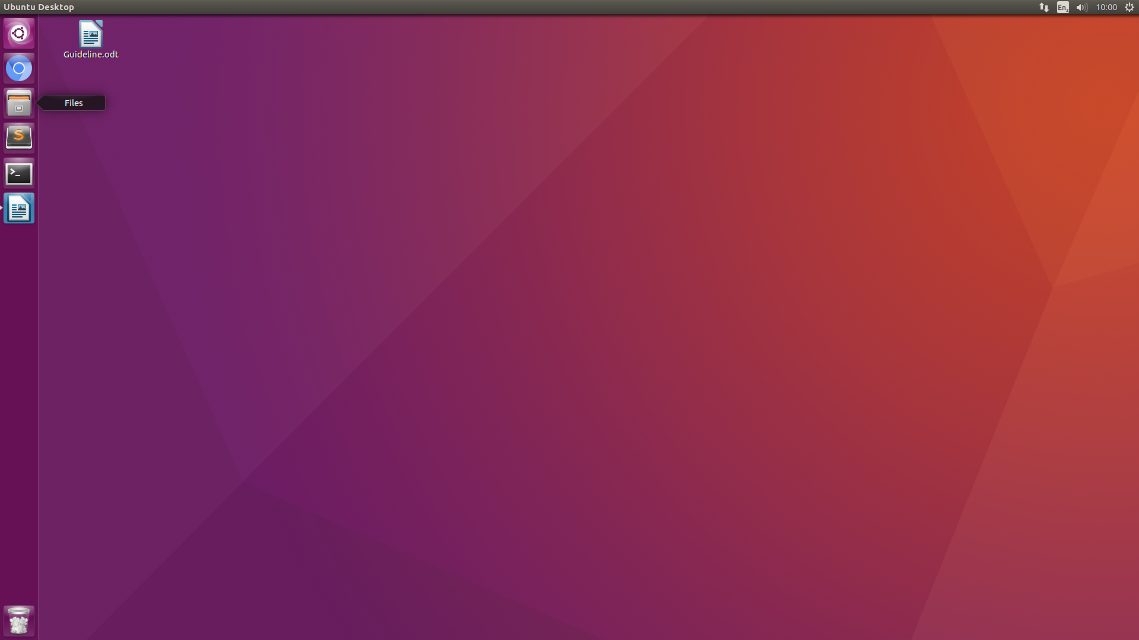
3. Open the folder scopus there.
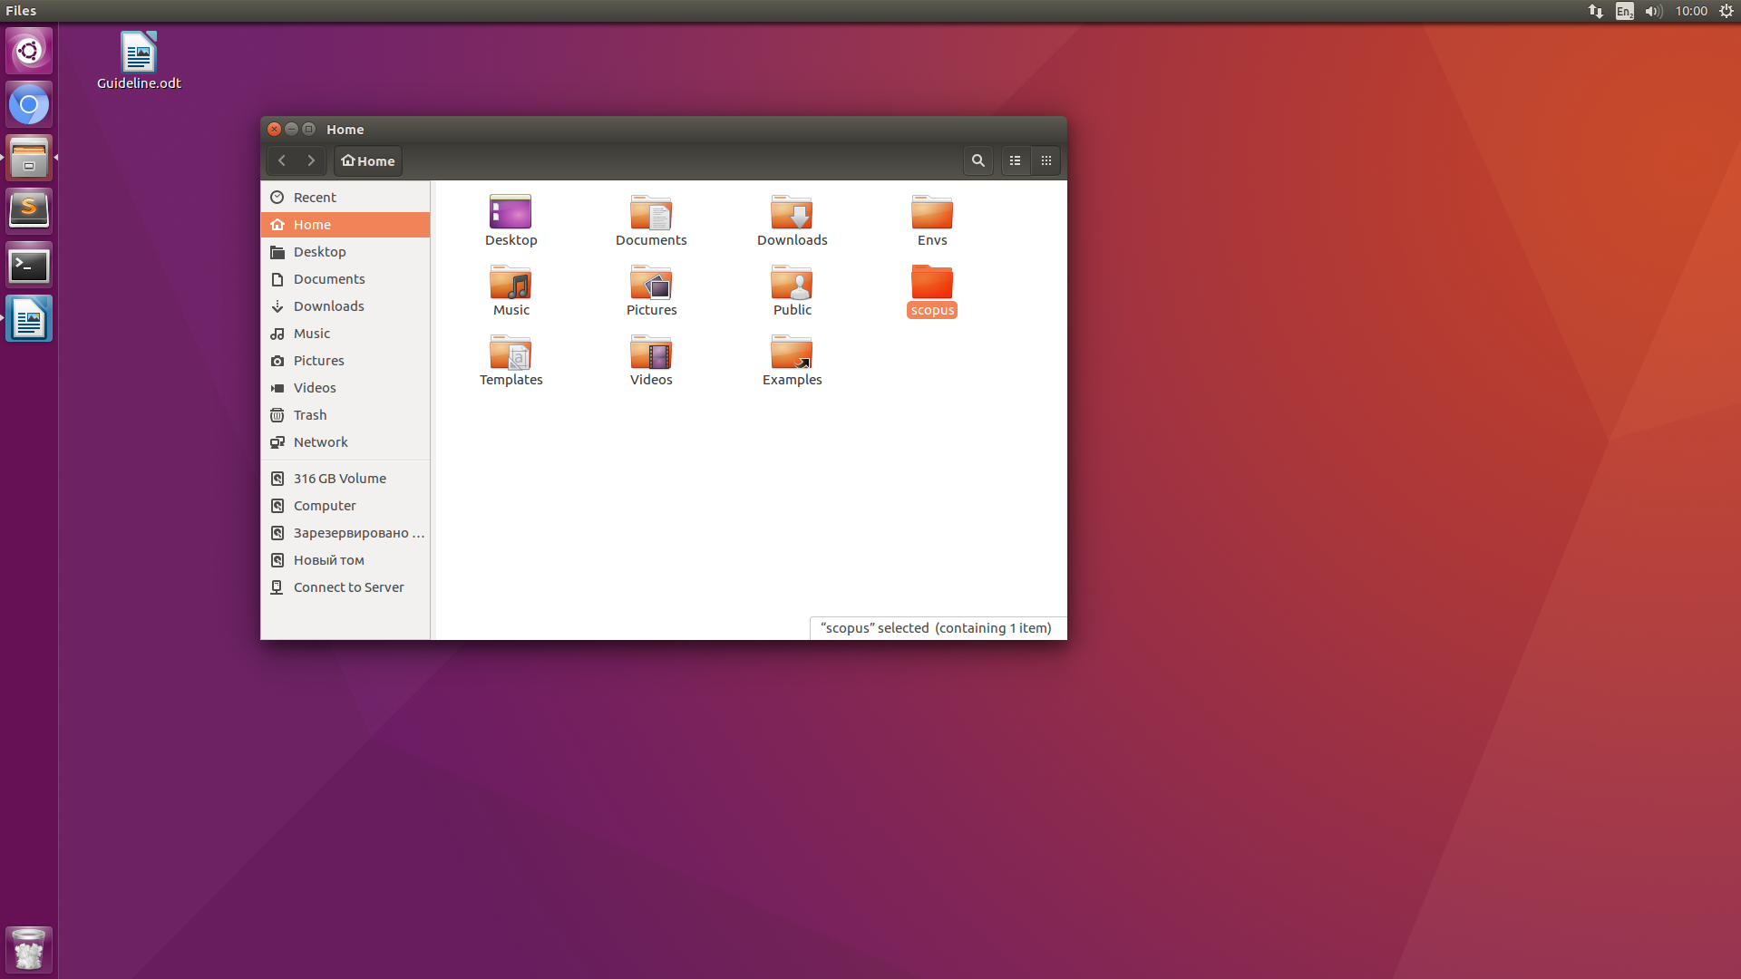

4. Open the file queries.txt.
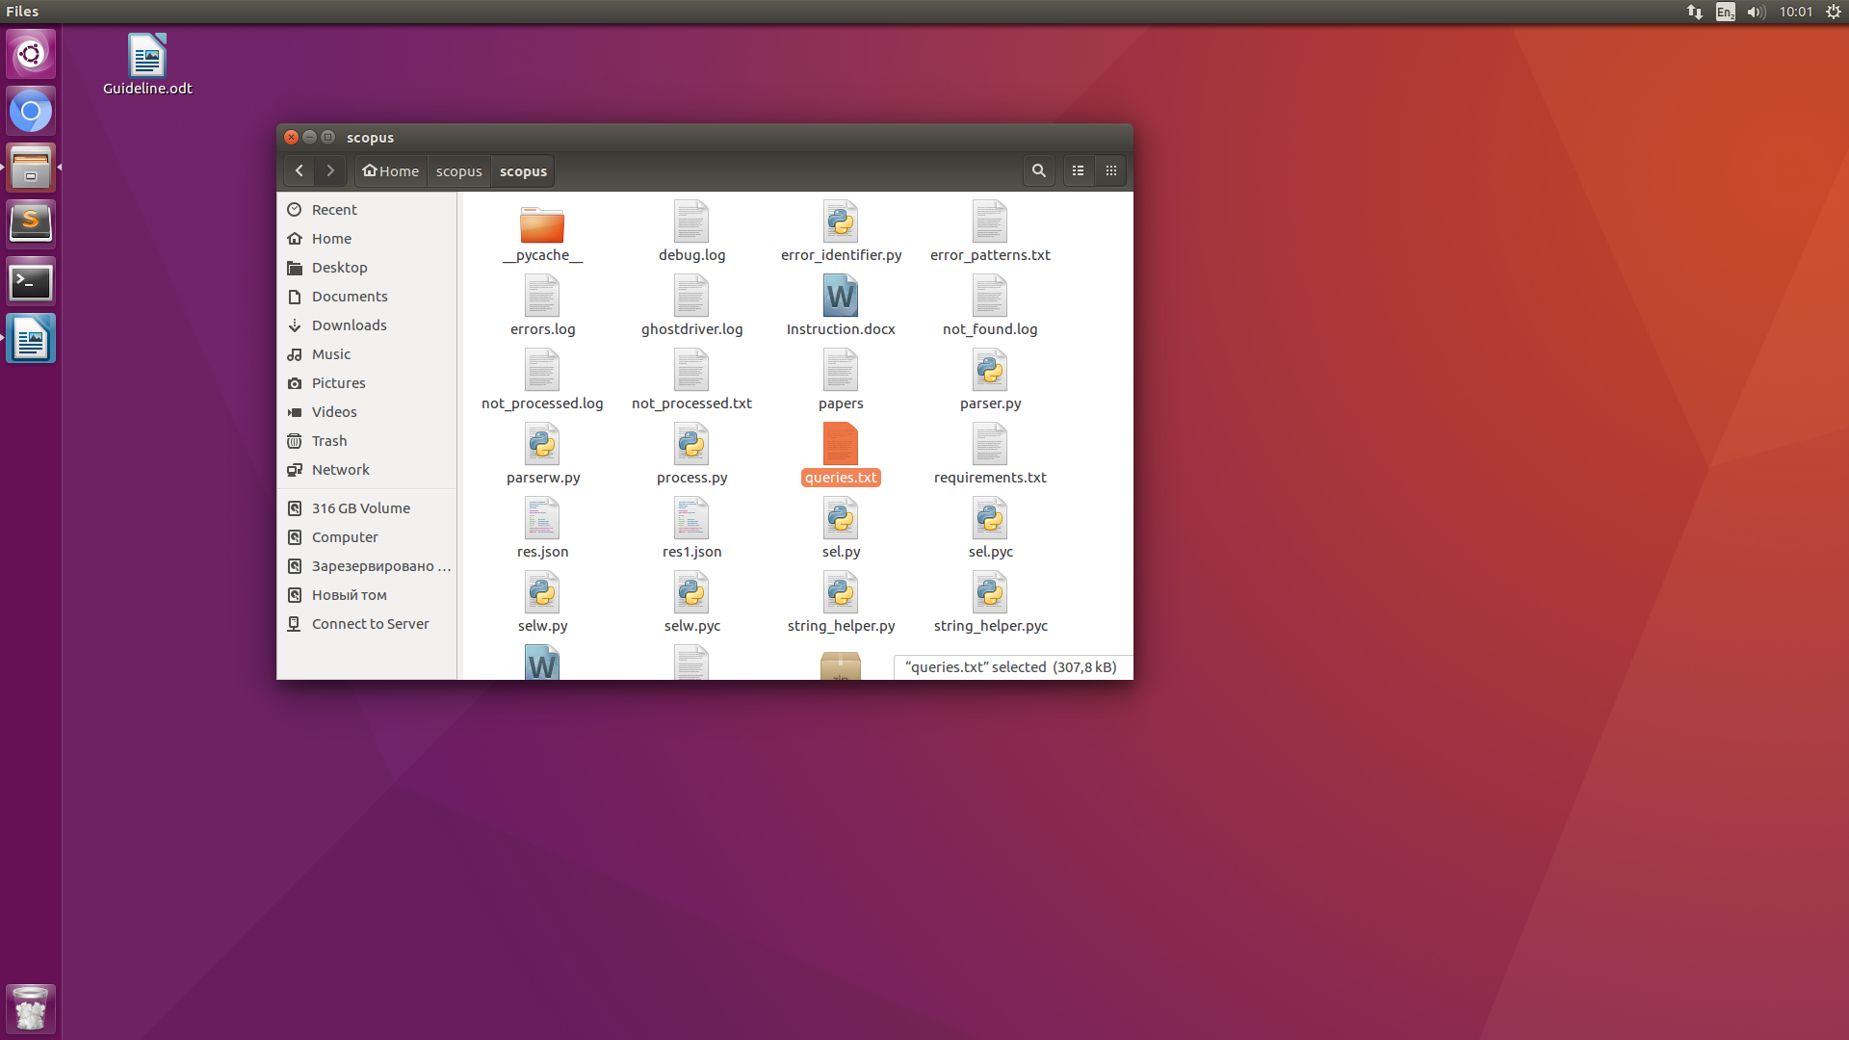
5. Copy all the queries from the file and erase them, and put the new queries. Then save the file and close the file and the the Files window.
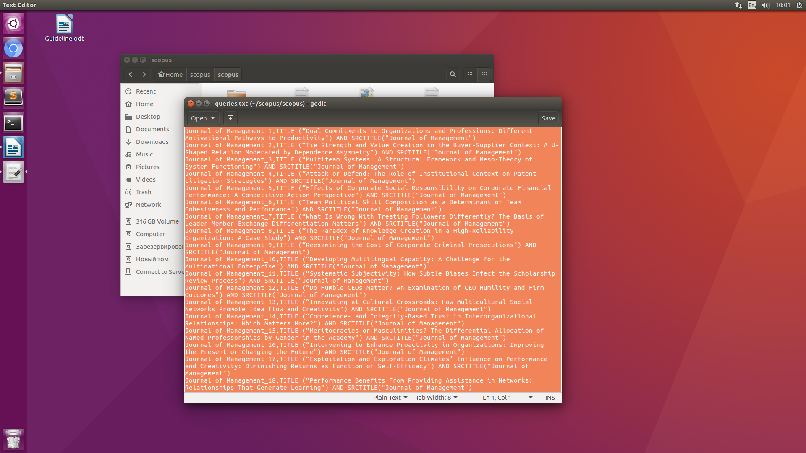

6. Press CONTROL+ALT+T together to open the Terminal
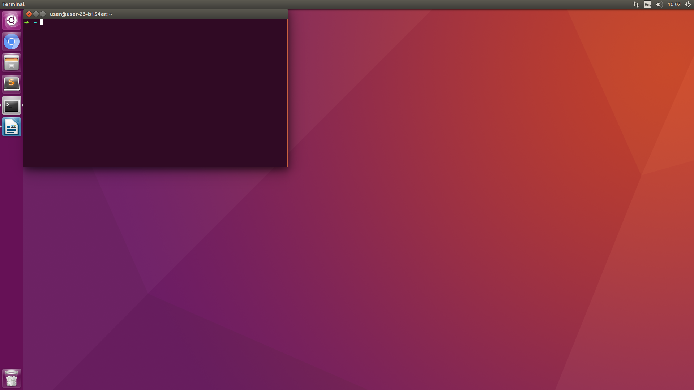
7. Type (or paste) in the Terminal this command:
cd ~/scopus

In order to paste the command, do it with Right Click of the mouse.
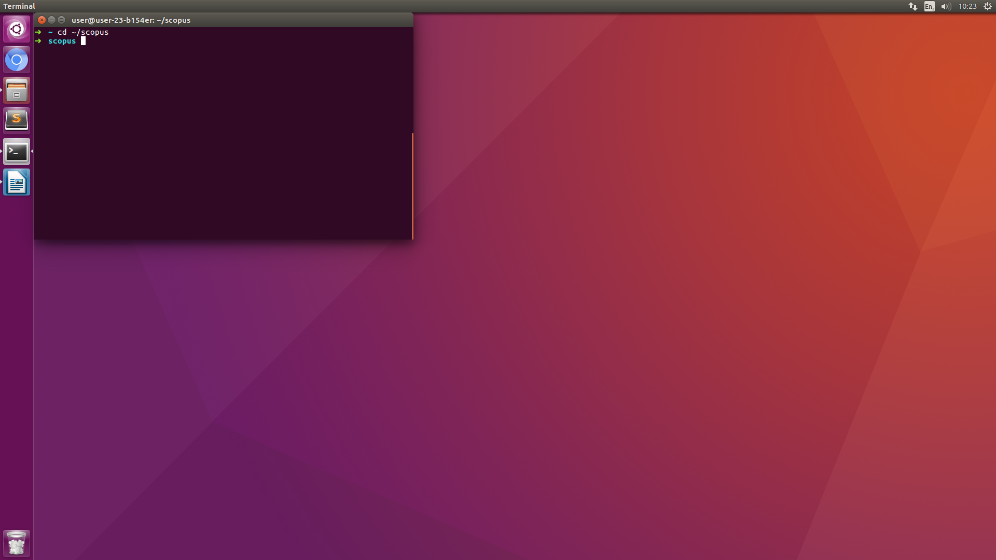

8. Type (or paste) in the Terminal this command:
workon scopus

In order to paste the command, do it with Right Click of the mouse.
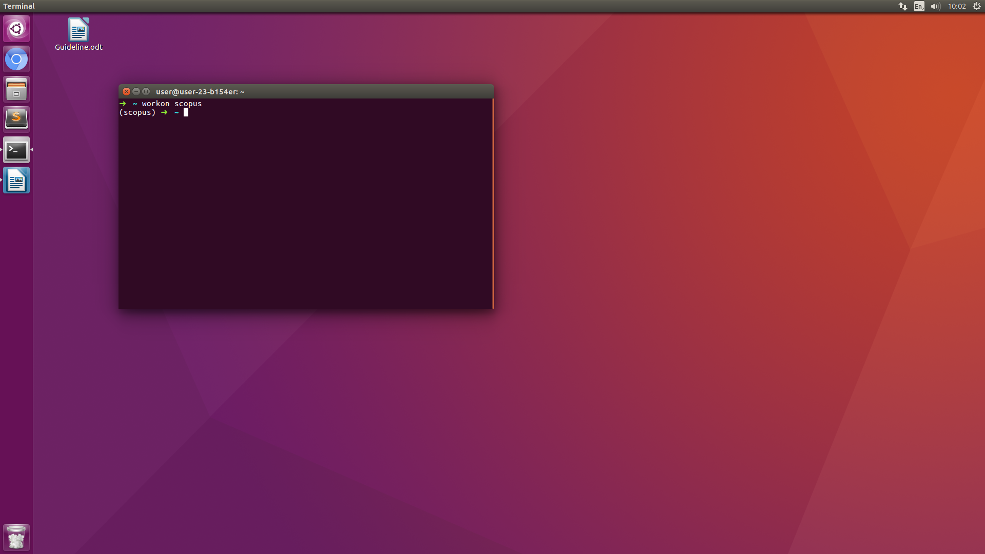
9. Type (or paste) in the Terminal this command:
python parser.py

In order to paste the command, do it with Right Click of the mouse.
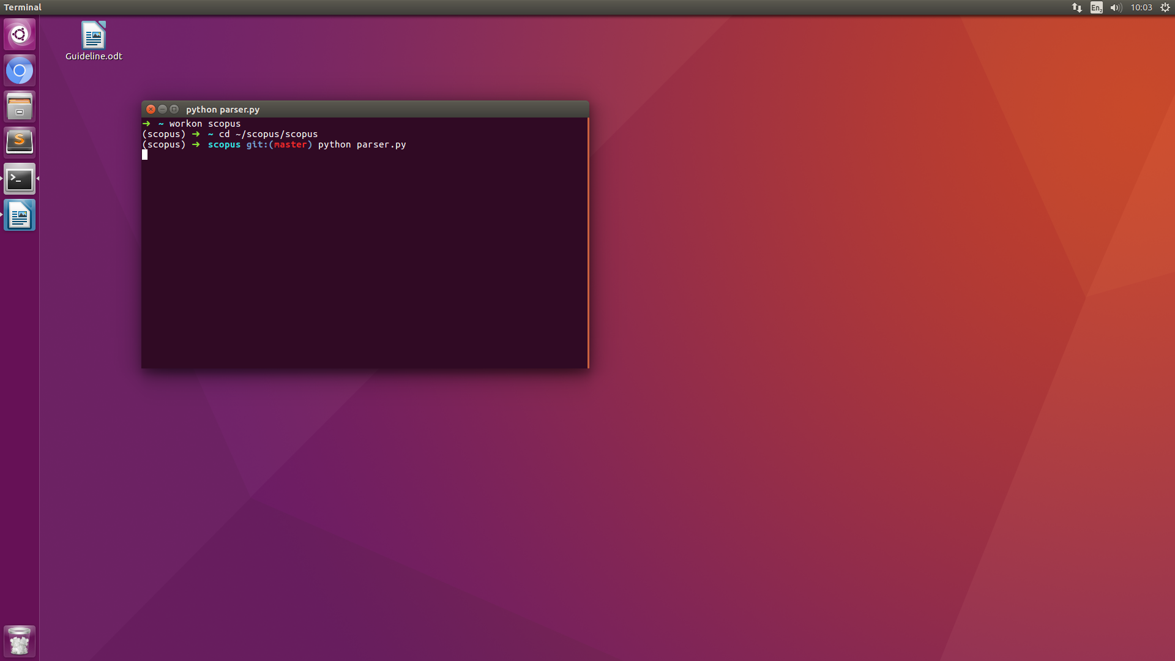

PART 2. PROCEEDING WITH ERROR QUERIES
1. Open the folder Files
2. Open the folder scopus

3. Open the file not_processed.txt
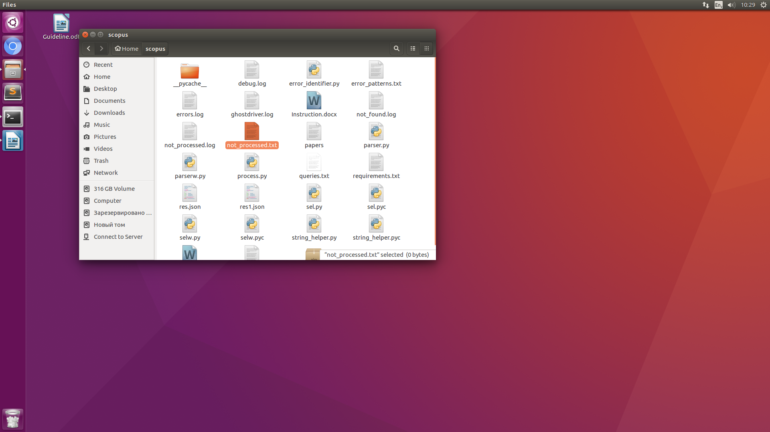
4. Copy all the queries from the file not_processed.txt and paste them in the file queries.txt. Erase everything from the file not_processed.txt. Close both files and the folder Files
5. Go to the p.6 of the PART 1.

